**Creating MSI Installer for Usermonitor**

**Overview**

This document provides a step-by-step guide to creating an MSI Installer for Usermonitor using Visual Studio Code 2022 and Advanced Installer.

**Prerequisites**

- Visual Studio Code 2022

- dotnet 7.0.12 runtime

- Microsoft Visual Studio Installer Projects Extension

**Procedure**

1. Open Visual Studio Code 2022

2. Create a New Project

3. Open the Usermonitor Files

- Navigate to the monitoruser and monitorservice files.

4. Modify Configuration

- Update necessary configurations like api url, installation directory,time intervals in the `appsettings.json` file for both monitoruser and monitorservice.

Note : Mainly Add the Product key in the monitoruser which you generated using Web UI.

  "ProductKey" : "YOUR PRODUCT KEY",

5. Create Setup Project

- Inside the project, create a new setup project by right click on project.

6. Add Project Output

- Create the monitoruser folder within the application folder.

- Right-click on the monitoruser folder and add the project output.

- In the pop-up, select the project file monitoruser and specify publish items in the text area box.

7. Create Shortcuts

- Within the monitor user folder, create shortcuts for the published items.

- Rename the shortcuts as "monitoruser".

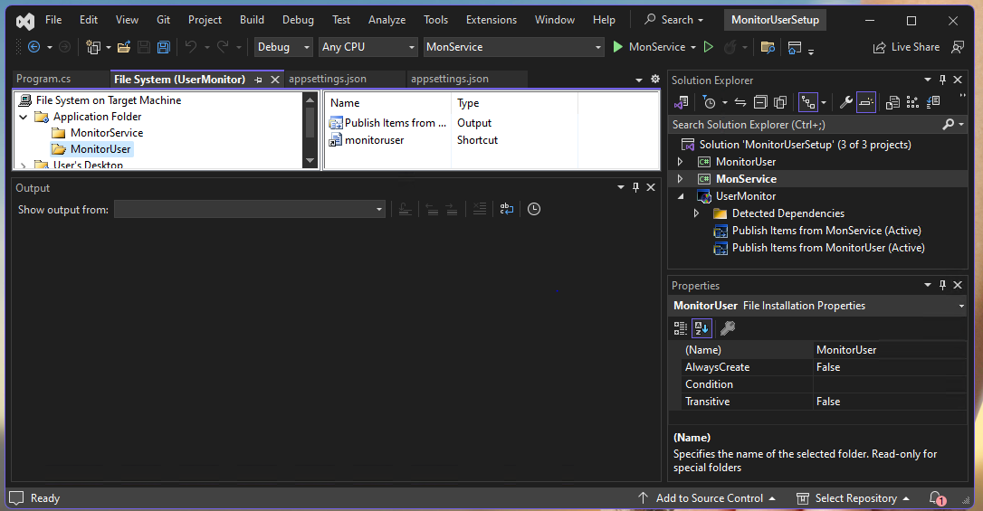

8. Repeat for monitorservice

- Repeat steps 6 and 7 for monitorservice.

9. Create Desktop Shortcuts

- Navigate to the user's desktop folder.

- Create two folders: monitor user and monitor service.

- Add shortcuts for both respective files by right-clicking and selecting "Create shortcut".

10. Build the setup project

- Right click on setup project and build the project.

11.Open the setup project on file explorer

- inside the debug folder you can find the UserMonitor exe.

**Note:** Kindly check the specified folder path after the software installation. During server shutdown, your data will be stored locally in the **User monitor** folder located within the current user's **App Data** directory.

Additional Resources

For more detailed instructions, refer to [Advanced Installer's guide](https://www.advancedinstaller.com/create-msi-installer-with-visual-studio.html).

**How to install Monitor Agent On-premises**

**Windows Agent :**

Need to install dotnet runtime - 7.0.12 version

Runtime Download link - <https://dotnet.microsoft.com/en-us/download/dotnet/thank-you/sdk-7.0.402-windows-x64-installer>

Installation of Individual User :

Need to install the Monitor agent application.

Open Task Scheduler

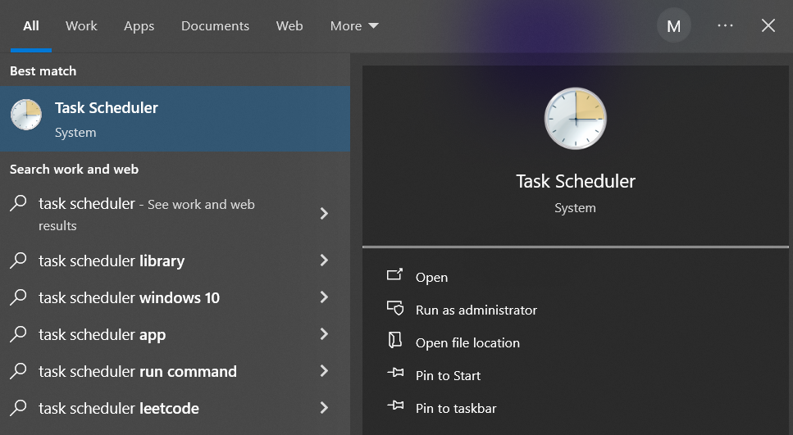

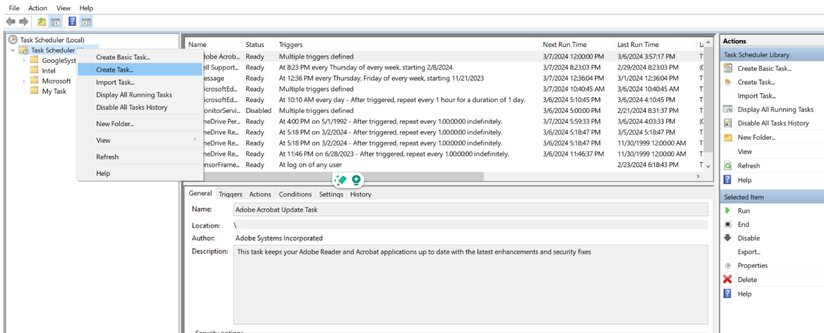

Select General Tab options, Enter the Task name

Select Which options you need “**Run only when user is logged’ on** or **“Run Whether user is logged on or not”**

Select Change User or Group – Depending upon based on your request select User or Group

Please create a Schedule, Log on & Startup triggers and refer the below mentioned Screenshots

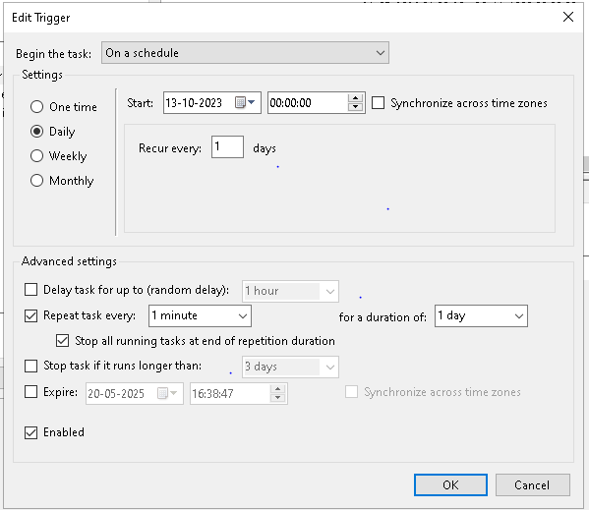

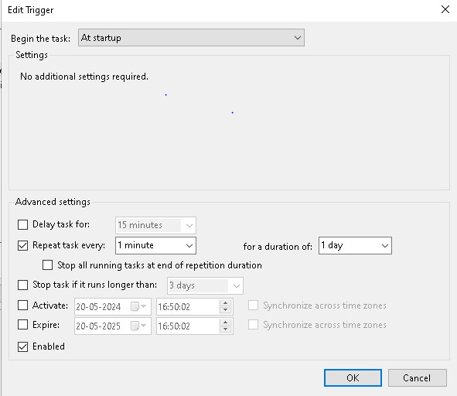

Go to Actions Tabs Select **New**

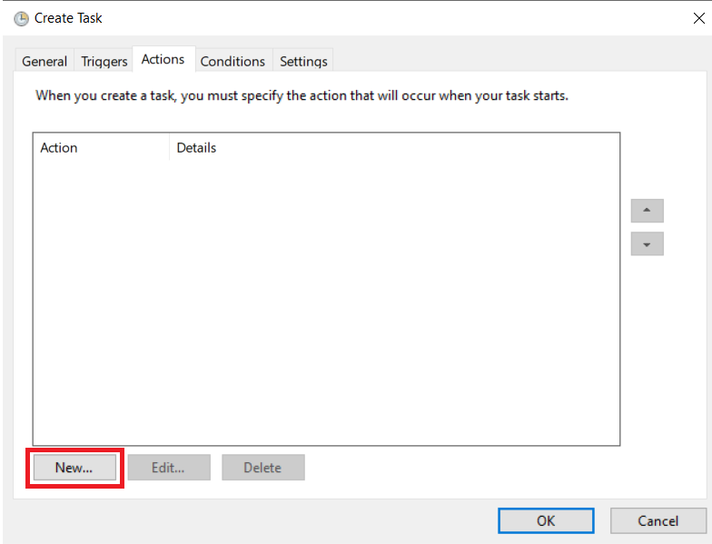

Click Browse -> select Monitor agent installation, Please refer below, we added the default location path

Program/Script - “**C:\Program Files (x86)\<UserName>\MonitorService\MonService.exe**”

Start in – “**C:\PROGRA~2\<Username>\MonitorService**”

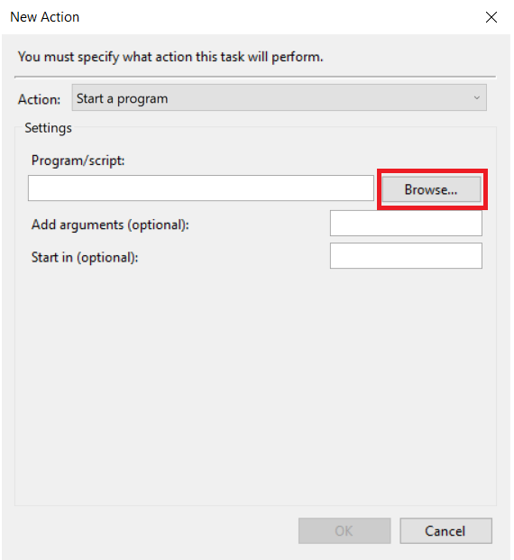

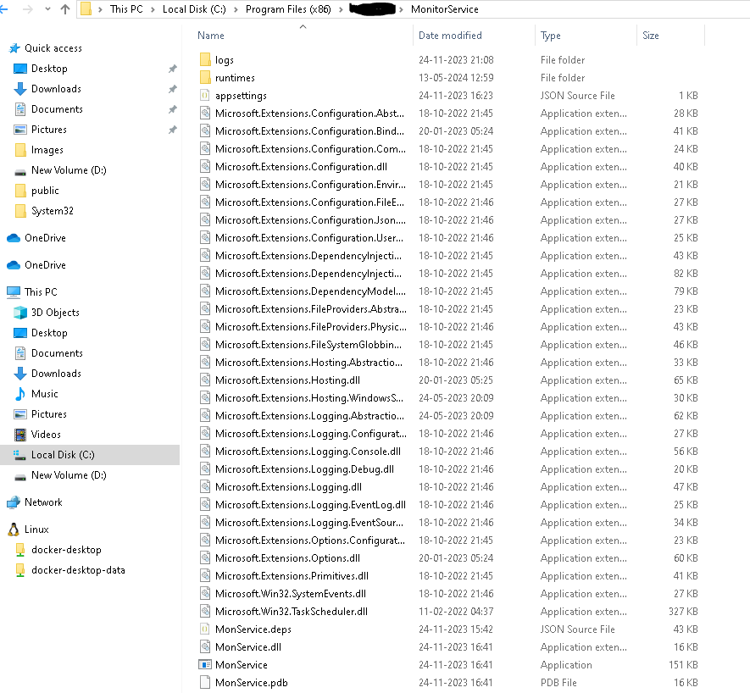

Go to the Settings tab, Refer to the below mentioned screenshot.

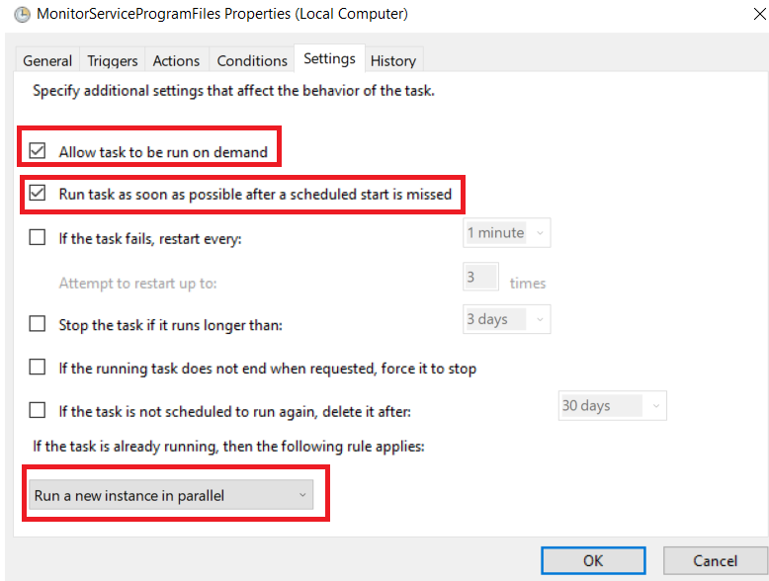

Click **Ok.**